Exercise 1: Understanding the Impact of Network Dynamics on Routing

Question 1. Which nodes communicate with which other nodes? Which route do the packets follow? Does it change over time?

0-5

2-5

The packets follow the path 0-1-4-5.

It doesn’t change over time.

Question 2: What happens at time 1.0 and at time 1.2? Does the route between the communicating nodes change as a result of that?

**At time 1.0, link 1-4 is down but the route does not change, so node 0 cannot reach to node 5.**

**At time 1.2, link 1-4 is up, the route goes as before, node 0 can reach to node 5.**

Question 3: Did you observe any additional traffic as compared to Step 3 above? How does the network react to the changes that take place at time 1.0 and time 1.2 now?

It consider the distance vector.

When the link 1-4 is down at time 1.0, the route is not changed at which state the node 0 cannot reach to node 5 in step 3, however additional traffic route which goes with 0-1-2-3-5 can link the node 0 and node 5.

When nodes 1-4 is down, a different route is discovered and node 0 can reach to node 5(0-1-2-3-5).

When the node is up again, the route goes as before(0-1-4-5).

Question 4: How does this change affect the routing? Explain why.

The route changes to 0-1-2-3-5, this is because the cost of link 1-4 is changed to 3(which is just 1 before), as a result the final cost of 0-1-4-5 is 5 while the route 0-1-2-3-5 is 4, so the network select the smaller cost link route.

Question 5: Describe what happens and deduce the effect of the line you just uncommented.

The route of the cost 0-1-4-5 is 4, and 0-1-2-3-5 is cost 6 so the route from node 0 to node 5 select the 0-1-4-5 because it costs less.

The route from node 2 to node 5 has two options, the first is 2-3-5 which is spend 4 and the other one is 2-1-4-5 which is spend 4. So both route have same cost, they can choose any route. The line of code “Node set multipath_ 1” means allow the node to goes with different route. So the route can be changed to select multipath when path has the same cost.

**Exercise 3: Understanding IP Fragmentation**

Question 1: Which data size has caused fragmentation and why? Which host/router has fragmented the original datagram? How many fragments have been created when data size is specified as 2000?

The data size of the fragmentation is 1480; because maximum transmission unit (MTU) is 1480, so larger size datagram require to be fragemented to prevent it being discarded somewhere along the path.

Both the source and destination hosts fragment the original datagram.

Two fragments are created when the data is 2000: 1480, 560

Question 2: Did the reply from the destination 8.8.8.8. for 3500-byte data size also get fragmented? Why and why not?

Yes, because destination host can fragment the datagram, and the maximum transmission unit (MTU) is 1448, so when sending 3500-byte data, it should be fragment to prevent it being discarded.

Question 3: Give the ID, length, flag and offset values for all the fragments of the first packet sent by 192.168.1.103 with data size of 3500 bytes?

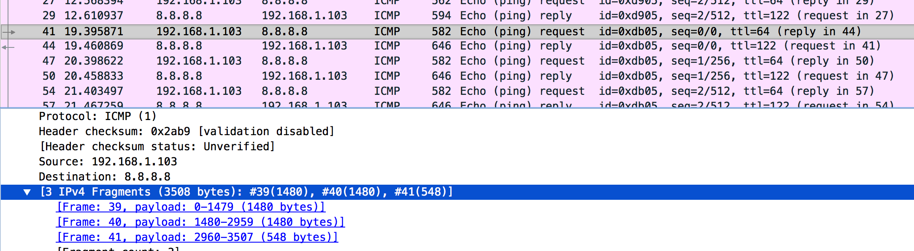

|  |  |  |  |
| --- | --- | --- | --- |
| ID | Length | Flag | Offset Value |
| #39 | 1480 | 0x0172 | 000 |
| #40 | 1480 | 0x0172 | 185 |
| #41 | 548 | 0x0172 | 370 |

Question 4: Has fragmentation of fragments occurred when data of size 3500 bytes has been used? Why and why not?

Yes, the fragments occurred when data of size 3500-byte, because 3500 byes larger than the maximum transmission unit (MTU), so larger size datagram is required to be fragemented to prevent it being discarded somewhere along the path.

Question 5: What will happen if for our example one fragment of the original datagram from 192.168.1.103 is lost?

The entire packet cannot be reassembled, so the entire packet will have to be resent since there's no mechanism to request a fragment be resent.